ODEL PLC

1. **INTRODUCTION**

* Project Title- The incurred losses in ODEL PLC
* Purpose of the project- To offer various strategies to aid ODEL in becoming profitable again

**Contents**

* **Dataset**: Cleaned and raw data files used for analysis.
* **Code**: Python scripts and Jupyter notebooks for data preprocessing, analysis, and visualization.
* **Presentation**: A summary of findings and recommendations.

1. **Problem statement and background**

* Problem description

Subsidiary companies like Odel have been experiencing consistent losses, raising concerns about their long-term sustainability under Softlogic Holdings PLC.

* Significance

It provides actionable strategies to address the root causes of financial losses, aiding in the company's turnaround which would help the stakeholders make informed decisions by analyzing data-driven insights.

* Background

Odel reported a loss of 1.7 billion LKR in 2023, a notable increase from 1.2 billion LKR compared to the previous year. This ongoing financial decline raises critical concerns about the ability of such subsidiaries to remain viable in the future.

**3. Gap analysis**

* Existing solutions

As for operational strategies, the group cites rationalizing and disposing of underused assets, as well as reviewing and rationalizing the outlet network with the aim of exiting low profitable locations.

Odel has closed loss-making stores Odel Battaramulla, Odel Majestic City, Cotton Collection Majestic City, and some exclusive branded outlets in Colombo City Centre, Liberty Plaza, and Kollupitiya. Love Moschino and Hallmark at One Galle Face Mall, and Crocs at Arcade Independence Square were also closed down. The Nugegoda department store was turned into a discount store. A new outlet was opened at Havelock City Mall.

The stakeholders have considered re-negotiating debt repayment plans, fresh infusions of equity, and raising Rs 10b through a rights issue and warrants, which have been announced.

* Limitations

Comprehensive research on consumer behavior and buying patterns.

There is limited research on the buying habits, lifestyle, and brand perception of Sri Lankan customers.

Competitor Analysis

There is inadequate research on how competitors to Odel in Sri Lanka affect its revenue

Efficiency of Operations

Little to no research on how Odel handles logistics, operational expenses, and management decisions which contribute to losses.

**4.** **Objectives and research questions**

* Main objective: To find possible solutions for Odel PLC to earn profit again
* Specific objectives:

Do particular expenses affect the profit Odel is incurring?

To find the relationship between the sales Odel achieves every year and why they make a loss even so.

To identify the challenges, they are facing with expenses

* Research questions

Why have some outlets gone out of business?

Is the amount of sales the main reason for the losses?

**5. Methodology**

* Data collection: The data was gathered using the Odel PLC annual reports.
* Data preprocessing: The dataset we used was not an existing dataset, the variables and values were derived from the annual report and were transformed into a dataset.

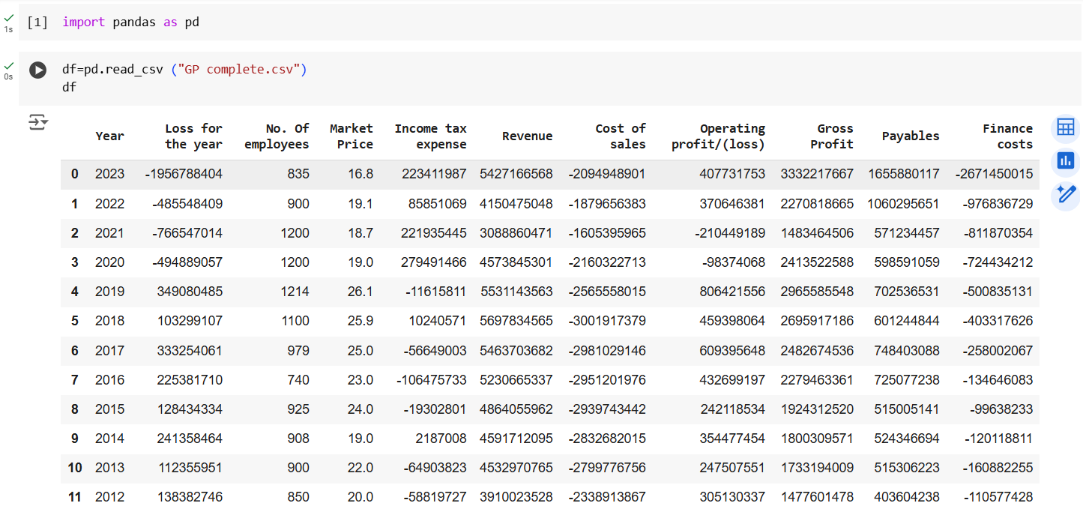

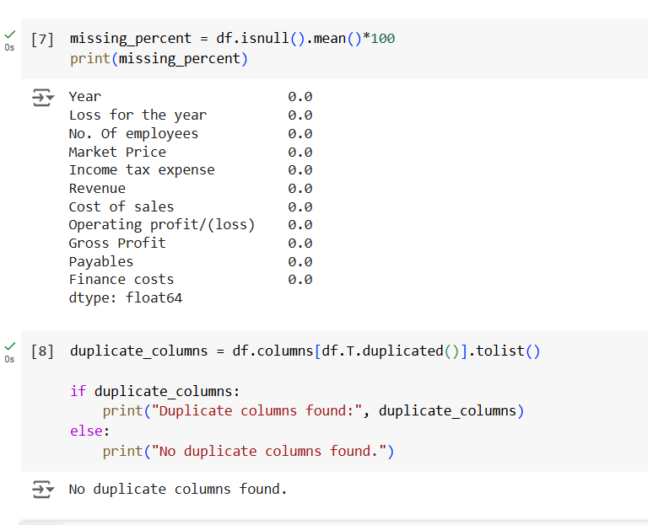

* 1. **Techniques and tools:** Excel, RStudio, Power BI, Google Colab
  2. **Analysis and findings**
* Visualizations
* Model performance
* Insights
  1. **Recommendations**
* optimize Outlet Network: Focus on high-performing outlets and re-evaluate the need for underperforming ones. Transition underused spaces into discount stores, as was done with the Nugegoda department store, while considering further expansion into profitable locations like Havelock City Mall.
* Invest in Market Research: Conduct detailed studies on customer buying behavior, preferences, and competitor strategies to tailor offerings and promotions better**.**
* Digital Transformation: Even though they have an online platform, it needs to be improved such as frequent posts and updates on the latest trends
  1. **Challenges and limitations**
* Limited Consumer Insights: The lack of comprehensive research on Sri Lankan customer behavior might hinder precise targeting and marketing.
* Financial Constraints: The ongoing financial losses of 1.7 billion LKR (as of 2023) restrict the availability of funds for research, technology upgrades, and strategic expansion.
* Debts: High debt levels and repayment obligations could overshadow efforts to improve operational efficiency and expand the business.
  1. **Impacts and Future work**

**Impacts**

* Increased profitability through streamlined operations and targeted marketing.
* Strengthened brand positioning by understanding consumer needs and preferences.
* Enhanced stakeholder confidence through visible improvements in performance metrics.

**Future Work**

* Conducting a deeper dive into customer analytics to better understand spending patterns and preferences.
* Expanding into digital retail platforms and enhancing customer experience through online services.

**Conclusion**

By addressing the key areas of operational inefficiencies, customer insights, and financial management, ODEL PLC can reverse its current losses and become a sustainable, profitable enterprise. With focused strategies and continuous adaptation, the company can retain its position as a leading retailer in Sri Lanka.